Nama : Setyorini

NIM : 23.01.53.6004

Tugas TESTING API NORTH WIND

1. GET ALL CUSTOMER AND DETAIL CUSTOMER

Url : <http://127.0.0.1/apiphp/api.php/recors/customers>

METHOD : GET

PIC :

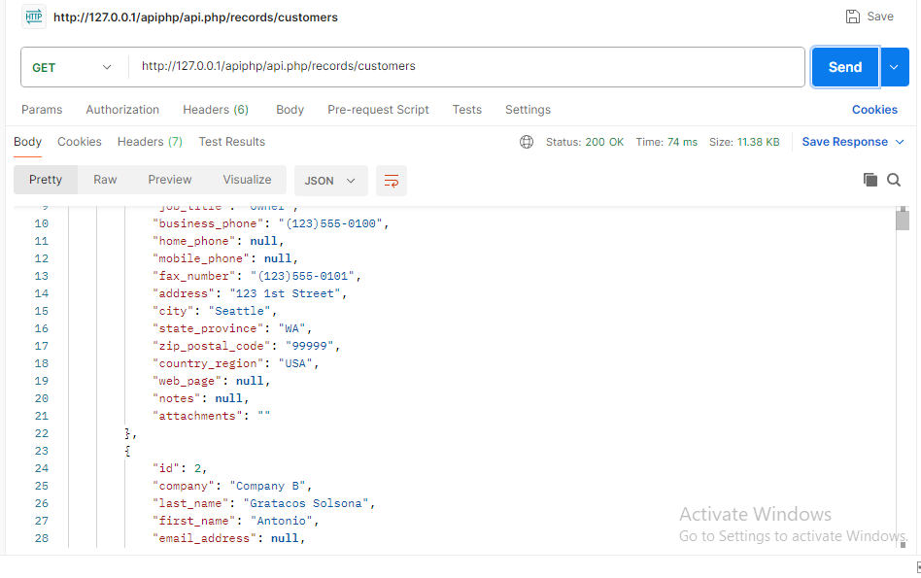

1. GET CUSTOMER AND DETAIL CUSTOMER BY ID

URL : <http://127.0.0.1/apiphp/api.php/records/customers/1>

METHOD : GET

PIC :

